**Project Design Phase-II**

**Technology Stack (Architecture & Stack)**

| Date | 03 October 2022 |
| --- | --- |
| Team ID | PNT2022TMID04781 |
| Project Name | SmartFarmer - IoT Enabled Smart Farming Application |
| Maximum Marks | 4 Marks |

**Technical Architecture:**

The Deliverable shall include the architectural diagram as below and the information as per the table1 & table 2

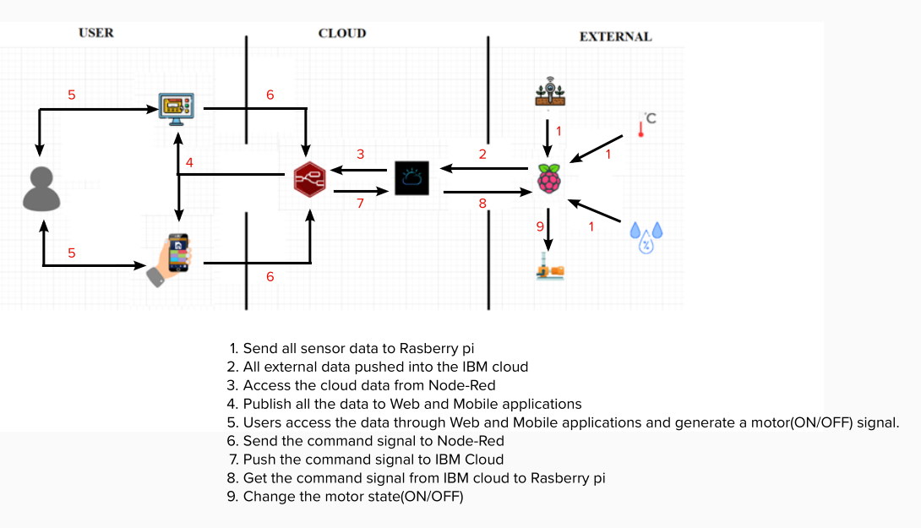

**Table-1: Components & Technologies:**

| **S.No** | **Component** | **Description** | **Technology** |
| --- | --- | --- | --- |
|  | User Interface | Web UI, Mobile App | Node-red, MIT app inventor |
|  | Application Logic-1 | Sensor data that is randomly generated | Python |
|  | Application Logic-2 | Sensor data is published and command signals are subscribed | IBM Watson IoT service |
|  | Application Logic-3 | Connect the cloud data to the web and Mobile Application | Node red |
|  | External API-1 | To generate the weather data if required | Open Weather API |
|  | External API-2 | To send an SMS to mobile devices | Fast2SMS API |
|  | Infrastructure (Server / Cloud) | Local Server Configuration (Mobile device) | MIT Mobile Application |

**Table-2: Application Characteristics:**

| **S.No** | **Characteristics** | **Description** | **Technology** |
| --- | --- | --- | --- |
|  | Open-Source Frameworks | MIT App Inventor, Node-Red | Website |
|  | Security Implementations | cloud integrations | API ID, API Token |
|  | Scalable Architecture | 2 – tier, Micro-services | Cloud, MQTT |
|  | Availability | 24x7 in IBM Cloud server | IBM Cloud |
|  | Performance | Lightweight Application, 200 requests/second, | Python, IBM Watson IoT platform |